CS 584-04: Machine Learning

Fall 2019 Assignment 1

# Question 1 (40 points)

Write a Python program to calculate the density estimator of a histogram. Use the field *x* in the NormalSample.csv file.

1. (5 points) According to Izenman (1991) method, what is the recommended bin-width for the histogram of x?

Ans: Bin width for histogram of X = 0.3998667554864773

1. (5 points) What are the minimum and the maximum values of the field x?

Ans: Minimum = 26.3

Maximum= 35.4

1. (5 points) Let a be the largest integer less than the minimum value of the field x, and b be the smallest integer greater than the maximum value of the field x. What are the values of a and b?

Ans: a = 26 b =36

1. (5 points) Use h = 0.1, minimum = a and maximum = b. List the coordinates of the density estimator. Paste the histogram drawn using Python or your favorite graphing tools.

Coordinates by density estimation: [0.0, 0.0, 0.00999000999000999, 0.0, 0.0, 0.0, 0.0, 0.0, 0.0, 0.0, 0.0, 0.00999000999000999, 0.0, 0.0, 0.0, 0.0, 0.01998001998001998, 0.0, 0.02997002997002997, 0.00999000999000999, 0.00999000999000999, 0.049950049950049945, 0.02997002997002997, 0.01998001998001998, 0.03996003996003996, 0.03996003996003996, 0.049950049950049945, 0.07992007992007992, 0.049950049950049945, 0.049950049950049945, 0.03996003996003996, 0.10989010989010987, 0.14985014985014983, 0.07992007992007992, 0.13986013986013984, 0.1898101898101898, 0.0899100899100899, 0.09990009990009989, 0.20979020979020976, 0.15984015984015984, 0.14985014985014983, 0.21978021978021975, 0.14985014985014983, 0.2797202797202797, 0.23976023976023975, 0.1898101898101898, 0.2697302697302697, 0.19980019980019978, 0.19980019980019978, 0.16983016983016982, 0.15984015984015984, 0.2797202797202797, 0.20979020979020976, 0.2797202797202797, 0.33966033966033965, 0.2597402597402597, 0.33966033966033965, 0.2697302697302697, 0.19980019980019978, 0.33966033966033965, 0.24975024975024973, 0.3196803196803197, 0.1898101898101898, 0.23976023976023975, 0.2797202797202797, 0.22977022977022976, 0.29970029970029965, 0.21978021978021975, 0.15984015984015984, 0.1898101898101898, 0.13986013986013984, 0.12987012987012986, 0.15984015984015984, 0.05994005994005994, 0.10989010989010987, 0.05994005994005994, 0.06993006993006992, 0.05994005994005994, 0.06993006993006992, 0.02997002997002997, 0.03996003996003996, 0.049950049950049945, 0.02997002997002997, 0.00999000999000999, 0.01998001998001998, 0.01998001998001998, 0.00999000999000999, 0.00999000999000999, 0.00999000999000999, 0.0, 0.0, 0.0, 0.00999000999000999, 0.00999000999000999, 0.0, 0.0, 0.0, 0.0, 0.0, 0.0]

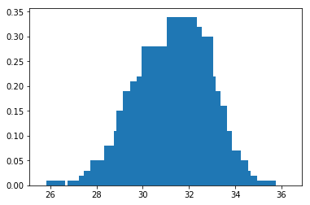

1. (5 points) Use h = 0.5, minimum = a and maximum = b. List the coordinates of the density estimator. Paste the histogram drawn using Python or your favorite graphing tools.

Coordinates by density estimation: [0.001998001998001998, 0.0, 0.001998001998001998, 0.011988011988011988, 0.029970029970029972, 0.053946053946053944, 0.1038961038961039, 0.14985014985014986, 0.2077922077922078, 0.2057942057942058, 0.25374625374625376, 0.2817182817182817, 0.25574425574425574, 0.21978021978021978, 0.11988011988011989, 0.057942057942057944, 0.029970029970029972, 0.00999000999000999, 0.003996003996003996, 0.0]

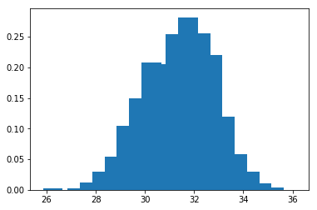

1. (5 points) Use h = 1, minimum = a and maximum = b. List the coordinates of the density estimator. Paste the histogram drawn using Python or your favorite graphing tools.

Coordinates by density estimation: [0.000999000999000999, 0.006993006993006993, 0.04195804195804196, 0.12687312687312688, 0.20679320679320679, 0.2677322677322677, 0.23776223776223776, 0.08891108891108891, 0.01998001998001998, 0.001998001998001998]

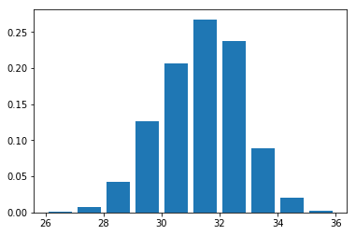

1. (5 points) Use h = 2, minimum = a and maximum = b. List the coordinates of the density estimator. Paste the histogram drawn using Python or your favorite graphing tools.

Coordinates by density estimation: [0.003996003996003996, 0.08441558441558442, 0.23726273726273725, 0.16333666333666333, 0.01098901098901099]

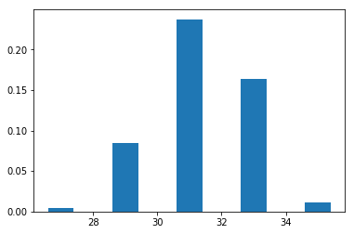

1. (5 points) Among the four histograms, which one, in your honest opinions, can best provide your insights into the shape and the spread of the distribution of the field x? Please state your arguments.

Among the four histograms, h=0.1 provides too accurate details but it doesn’t provide the insight for the shape. Whereas h=1 and h=2 though has the shape as clear as water it doesn’t provide much details to notice. So I believe h=0.5 would be considered the best among the four.

# Question 2 (20 points)

Use in the NormalSample.csv to generate box-plots for answering the following questions.

1. (5 points) What is the five-number summary of x? What are the values of the 1.5 IQR whiskers?

Min Q-25 Q-50 Q-75 Max

26.3 30.4 31.5 32.4 35.4

1.5 IQR whiskers = 27.4 , 35.4

1. (5 points) What is the five-number summary of x for each category of the group? What are the values of the 1.5 IQR whiskers for each category of the group?

Group – 0

Min Q-25 Q-50 Q-75 Max

26.3 29.4 30. 30.6 32.2

1.5 IQR whiskers

27.599999999999994

32.400000000000006

Group-1

Min Q-25 Q-50 Q-75 Max

29.1 31.4 32.1 32.7 35.4

1.5 IQR whiskers

29.449999999999992

34.650000000000006

1. (5 points) Draw a boxplot of x (without the group) using the Python boxplot function. Can you tell if the Python’s boxplot has displayed the 1.5 IQR whiskers correctly?

The 1.5 IQR whisker values are min = 27.4 and max = 35.4 and if you observe from the group 0 and group 1 values of 1.5 IQR whiskers then it is min = 27.5 and max = 34.65 which is nearly equal and the difference is negligible. Hence i would say that it has plotted correctly.

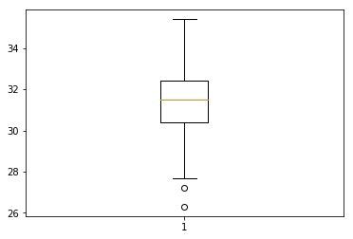

1. (5 points) Draw a graph where it contains the boxplot of x, the boxplot of x for each category of Group (i.e., three boxplots within the same graph frame). Use the 1.5 IQR whiskers, identify the outliers of x, if any, for the entire data and for each category of the group.  
   *Hint: Consider using the CONCAT function in the PANDA module to append observations*.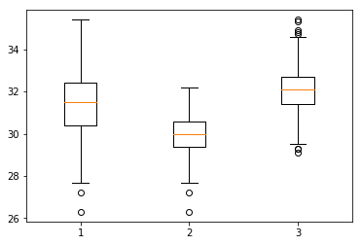

# Question 3 (40 points)

The data, FRAUD.csv, contains results of fraud investigations of 5,960 cases. The binary variable FRAUD indicates the result of a fraud investigation: 1 = Fraudulent, 0 = Otherwise. The other interval variables contain information about the cases.

1. TOTAL_SPEND: Total amount of claims in dollars
2. DOCTOR_VISITS: Number of visits to a doctor
3. NUM_CLAIMS: Number of claims made recently
4. MEMBER_DURATION: Membership duration in number of months
5. OPTOM_PRESC: Number of optical examinations
6. NUM_MEMBERS: Number of members covered

You are asked to use the Nearest Neighbors algorithm to predict the likelihood of fraud.

1. (5 points) What percent of investigations are found to be fraudulent? Please give your answer up to 4 decimal places.

Fraud % = 19.9497

1. (5 points) Use the BOXPLOT function to produce horizontal box-plots. For each interval variable, one box-plot for the fraudulent observations, and another box-plot for the non-fraudulent observations. These two box-plots must appear in the same graph for each interval variable.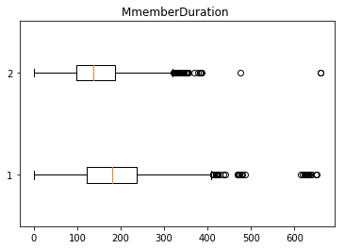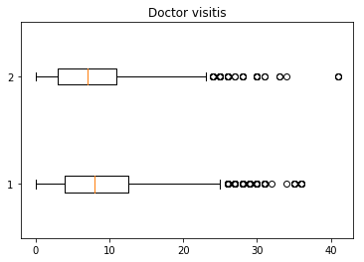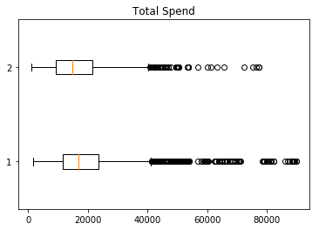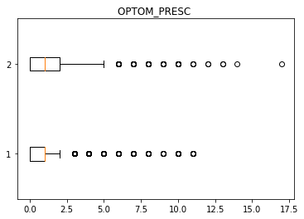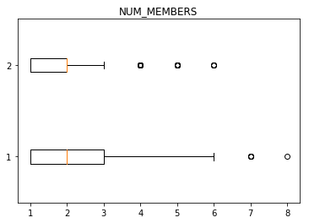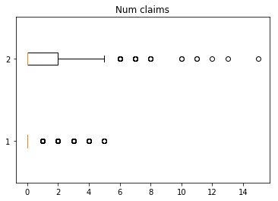
2. (10 points) Orthonormalize interval variables and use the resulting variables for the nearest neighbor analysis. Use only the dimensions whose corresponding eigenvalues are greater than one.
   1. (5 points) How many dimensions are used?

Ans: 6

* 1. (5 points) Please provide the transformation matrix? You must provide proof that the resulting variables are actually orthonormal.

Transformation Matrix =

[[-6.49862374e-08 -2.41194689e-07 2.69941036e-07 -2.42525871e-07

-7.90492750e-07 5.96286732e-07]

[ 7.31656633e-05 -2.94741983e-04 9.48855536e-05 1.77761538e-03

3.51604254e-06 2.20559915e-10]

[-1.18697179e-02 1.70828329e-03 -7.68683456e-04 2.03673350e-05

1.76401304e-07 9.09938972e-12]

[ 1.92524315e-06 -5.37085514e-05 2.32038406e-05 -5.78327741e-05

1.08753133e-04 4.32672436e-09]

[ 8.34989734e-04 -2.29964514e-03 -7.25509934e-03 1.11508242e-05

2.39238772e-07 2.85768709e-11]

[ 2.10964750e-03 1.05319439e-02 -1.45669326e-03 4.85837631e-05

6.76601477e-07 4.66565230e-11]]

If you multiply the transformed X matrix with its transpose then it should give identity matrix like this.

transformedX = np.matmul(x,transformationMatrix)

xtx = np.matmul(transformedX.transpose(),transformedX);

[[ 1. -0. 0. -0. 0. -0.]

[-0. 1. 0. 0. -0. -0.]

[ 0. 0. 1. -0. -0. 0.]

[-0. 0. -0. 1. -0. 0.]

[ 0. -0. -0. -0. 1. 0.]

[-0. -0. 0. 0. 0. 1.]]

1. (10 points) Use the NearestNeighbors module to execute the Nearest Neighbors algorithm using exactly five neighbors and the resulting variables you have chosen in c). The KNeighborsClassifier module has a score function.
   1. (5 points) Run the score function, provide the function return value

Ans: 0.8778523489932886

* 1. (5 points) Explain the meaning of the score function return value.

It provides the accuracy of the values and the data given. This is based on the training and the testing data values provided to the scikit functions from the scikit libraries.

1. (5 points) For the observation which has these input variable values: TOTAL_SPEND = 7500, DOCTOR_VISITS = 15, NUM_CLAIMS = 3, MEMBER_DURATION = 127, OPTOM_PRESC = 2, and NUM_MEMBERS = 2, find its **five** neighbors. Please list their input variable values and the target values. *Reminder: transform the input observation using the results in c) before finding the neighbors*.

CASE_ID 589

FRAUD 1

TOTAL_SPEND 7500

DOCTOR_VISITS 15

NUM_CLAIMS 3

MEMBER_DURATION 127

OPTOM_PRESC 2

NUM_MEMBERS 2

Name: 588, dtype: int64

----------------------------------------------------------------

CASE_ID 2898

FRAUD 1

TOTAL_SPEND 16000

DOCTOR_VISITS 18

NUM_CLAIMS 3

MEMBER_DURATION 146

OPTOM_PRESC 3

NUM_MEMBERS 2

Name: 2897, dtype: int64

----------------------------------------------------------------

CASE_ID 1200

FRAUD 1

TOTAL_SPEND 10000

DOCTOR_VISITS 16

NUM_CLAIMS 3

MEMBER_DURATION 124

OPTOM_PRESC 2

NUM_MEMBERS 1

Name: 1199, dtype: int64

----------------------------------------------------------------

CASE_ID 1247

FRAUD 1

TOTAL_SPEND 10200

DOCTOR_VISITS 13

NUM_CLAIMS 3

MEMBER_DURATION 119

OPTOM_PRESC 2

NUM_MEMBERS 3

Name: 1246, dtype: int64

----------------------------------------------------------------

CASE_ID 887

FRAUD 1

TOTAL_SPEND 8900

DOCTOR_VISITS 22

NUM_CLAIMS 3

MEMBER_DURATION 166

OPTOM_PRESC 1

NUM_MEMBERS 2

Name: 886, dtype: int64

1. (5 points) Follow-up with e), what is the predicted probability of fraudulent (i.e., FRAUD = 1)? If your predicted probability is greater than or equal to your answer in a), then the observation will be classified as fraudulent. Otherwise, non-fraudulent. Based on this criterion, will this observation be misclassified?

Ans: The predicted probability for the above cases is 1 (FRAUD=1). Hence it is greater than the answer I obtained in (a). so based on that we can conclude that this won’t be misclassified.